**The polymer consistent force field (PCFF)**

In the PCFF, the potential energy can be expressed as:

*Etotal = Evalence + Ecross-term + Enon-bond*

Evalence is the valence energy, which has a bond stretching term, an angle term, a torsion term, and an out-ofplane term. The *E*cross-term is a cross-term that illustrates the special effects such as bond lengths and angle changes caused by the adjacent atoms. *E*non-bond are non-bond terms  
that explain the interaction between non-bonded atoms, which include van der Waals energy and Coulomb electrostatic interactions.

**Relation b/w MSD & Self diffusion coefficient**

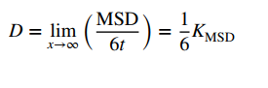

**Proximal distribution function**

The proximal distribution function quantifies the probability of finding a solvent molecule in the vicinity of solutes.

**Superficies**

A surface of a body or a region of space.